Gold Price Analytics Project
Complete submission with real dataset, notebook-based workflow, charts, model output, and final insights.
Name: Ritesh Wasekar
Roll Number: SA223
Project Title: Gold Price Analytics using Real Monthly Historical Data
Problem Statement: I analyzed a real gold price dataset to understand how gold prices changed over time and what patterns are visible in long-term historical data. This project helps explain long-run price movement and monthly volatility in simple terms.
Dataset Description: The source dataset contains monthly gold prices in USD since 1833. For this project, the analytical dataset has 2319 rows and 8 columns after adding time-based and change-based features for better analysis.

Import Libraries
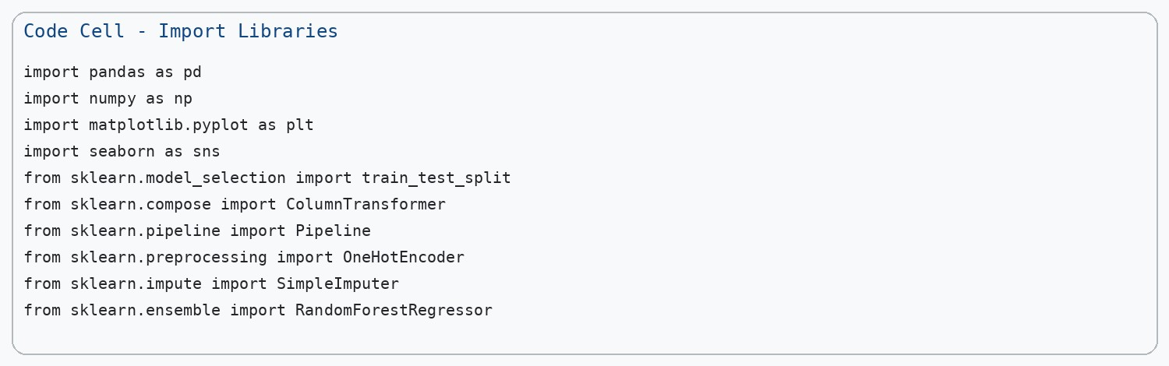
All required libraries were imported in one code cell so the notebook can run cleanly from top to bottom.

Load Dataset and Prepare Columns
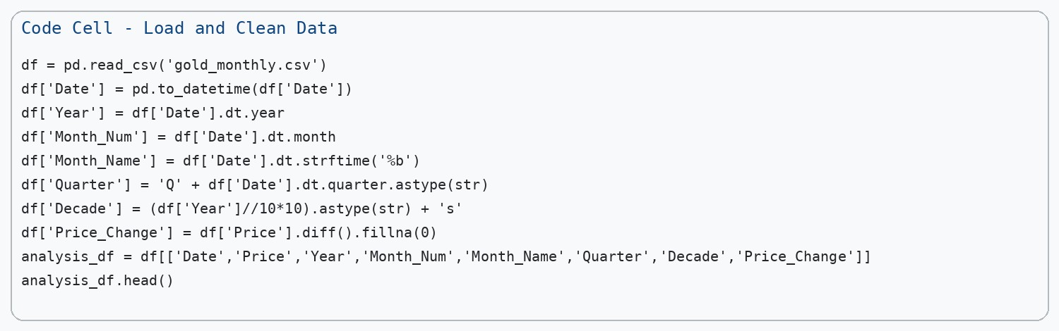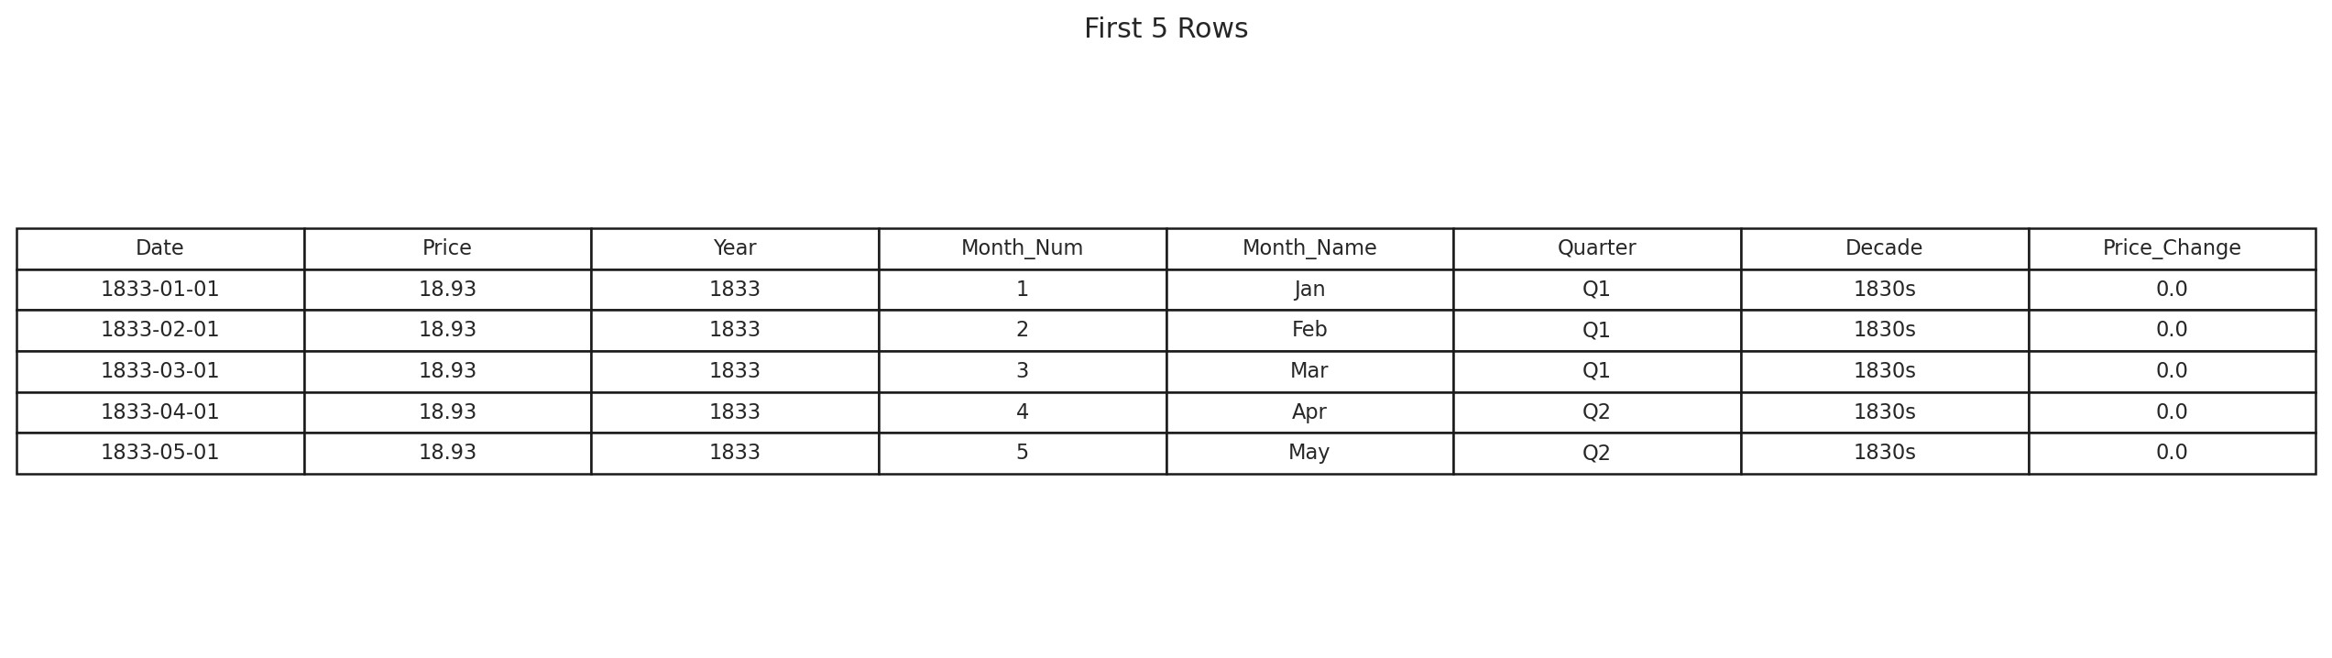
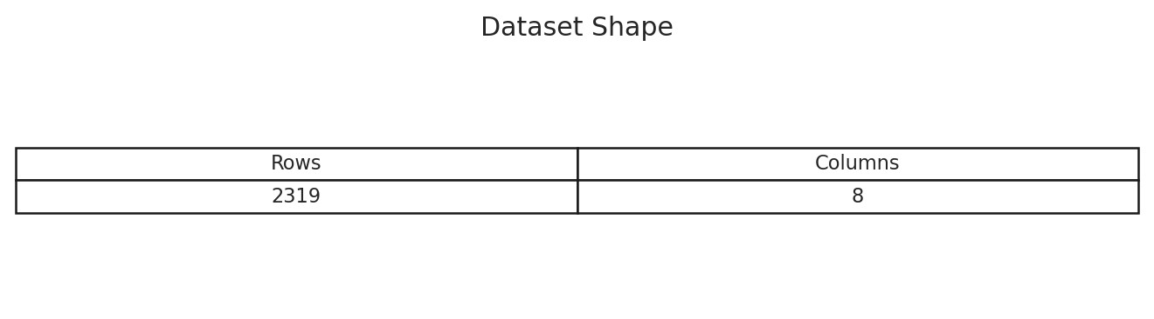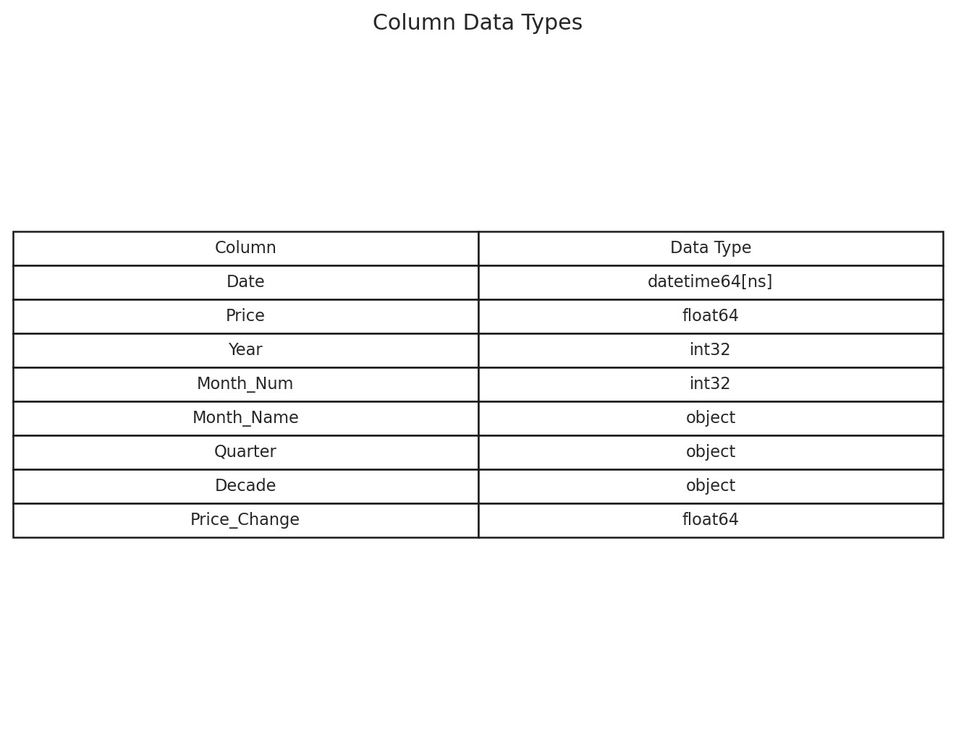
The dataset includes one original numeric column (`Price`) and several derived columns such as `Month_Name`, `Quarter`, and `Decade`, which provide the required categorical information for analysis and prediction.

Data Cleaning
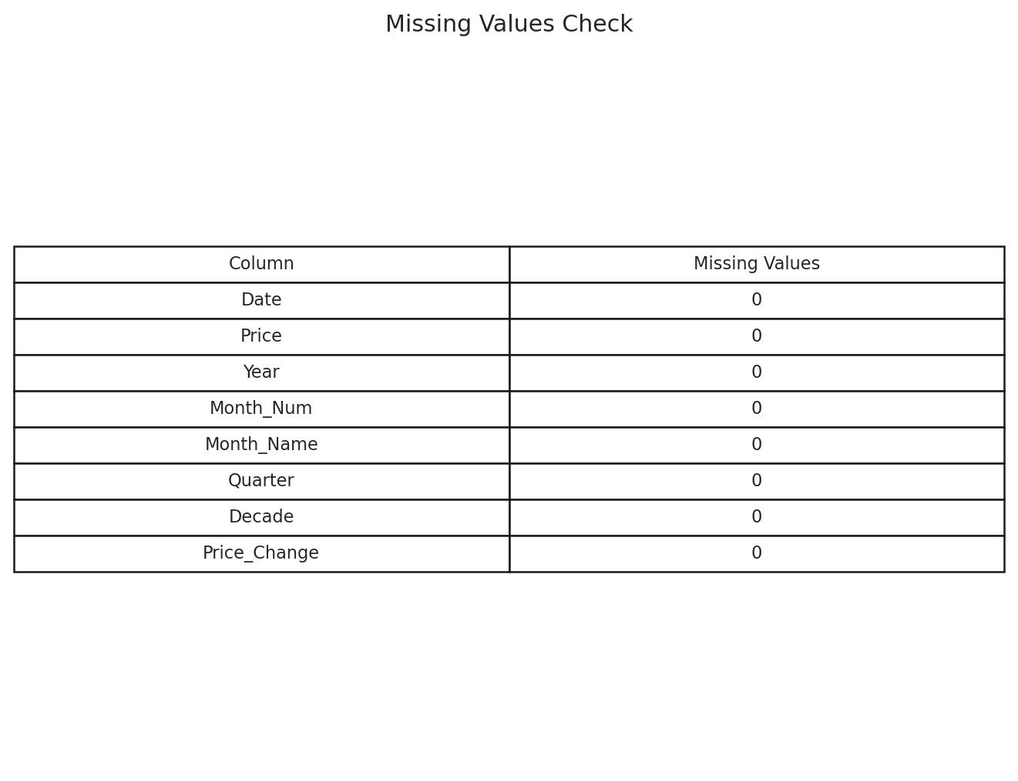
No missing values remained in the final dataset. The first `Price_Change` value, which can be empty after a difference operation, was filled with 0, and duplicate rows were removed if present.

Statistical Analysis
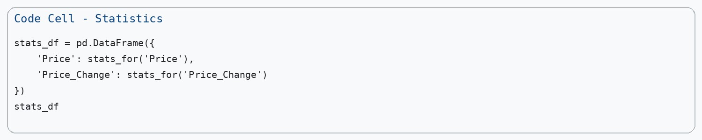
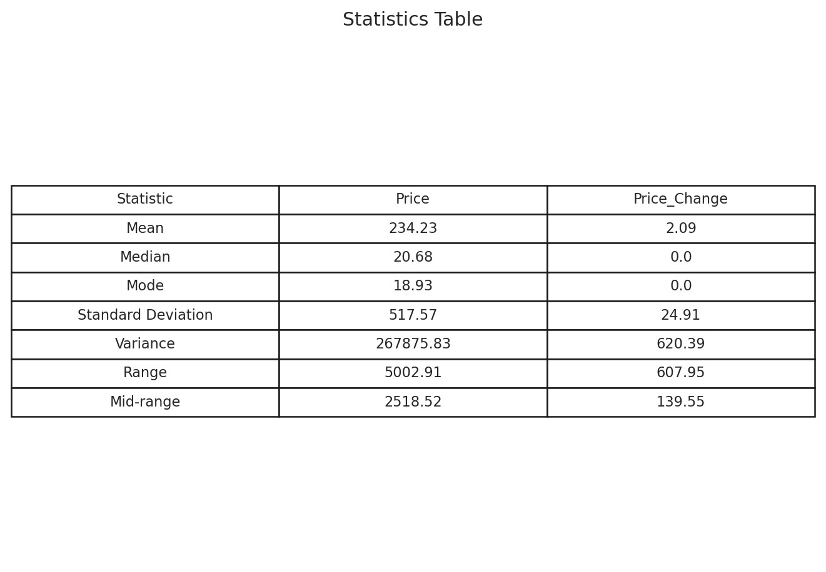
The average gold price is 234.23, while the median is 20.68. Since the mean is much larger than the median, the distribution is influenced by high prices in recent years.

Visualizations
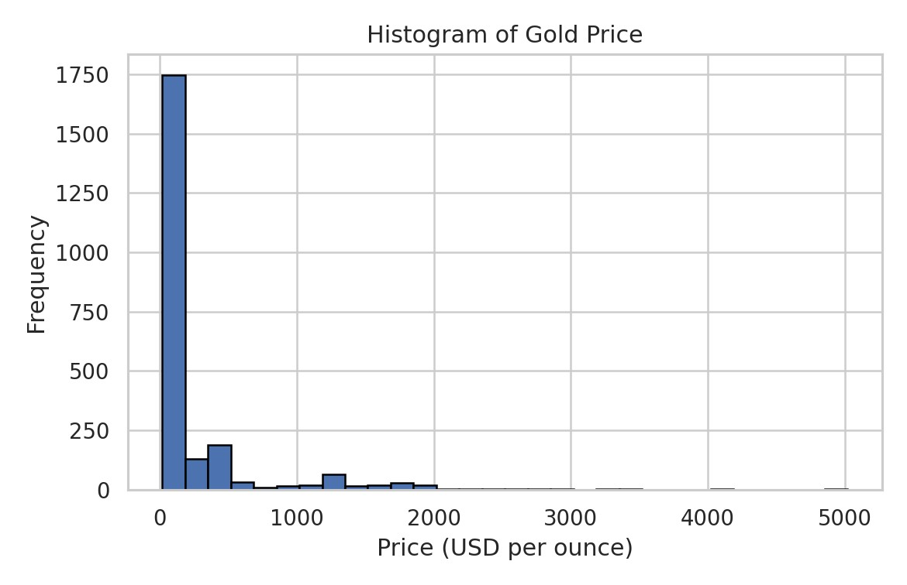
Histogram interpretation: The price distribution is right-skewed, meaning lower historical prices appear much more frequently than recent high prices.
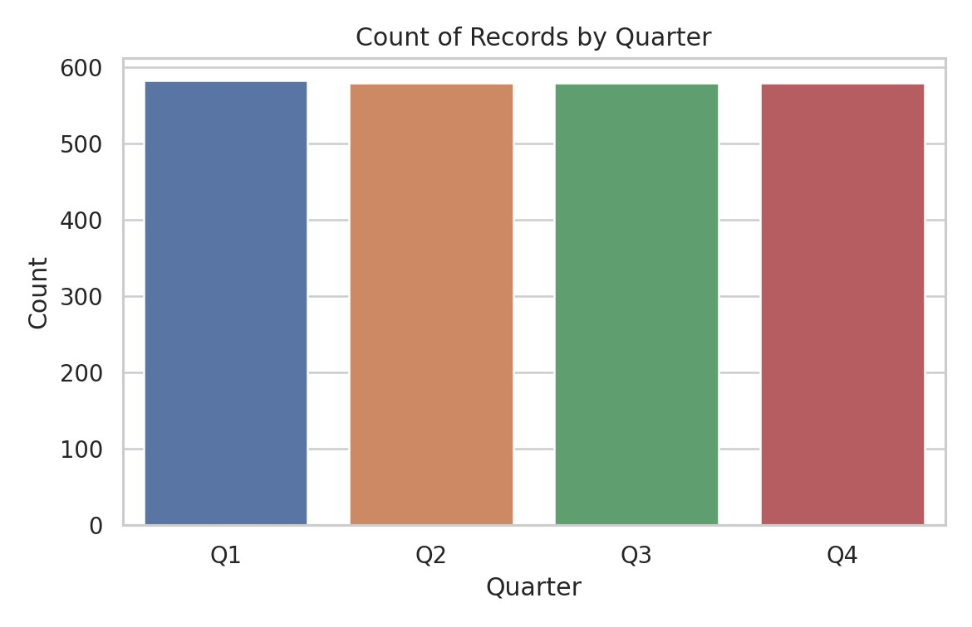
Countplot interpretation: Each quarter has almost the same number of records because the dataset has one record per month across many years.
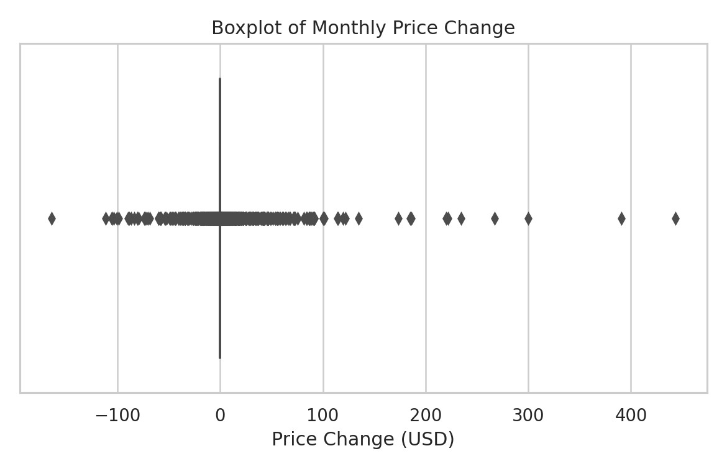
Boxplot interpretation: There are several outliers in monthly price change, which means some months had unusually sharp price increases or decreases.
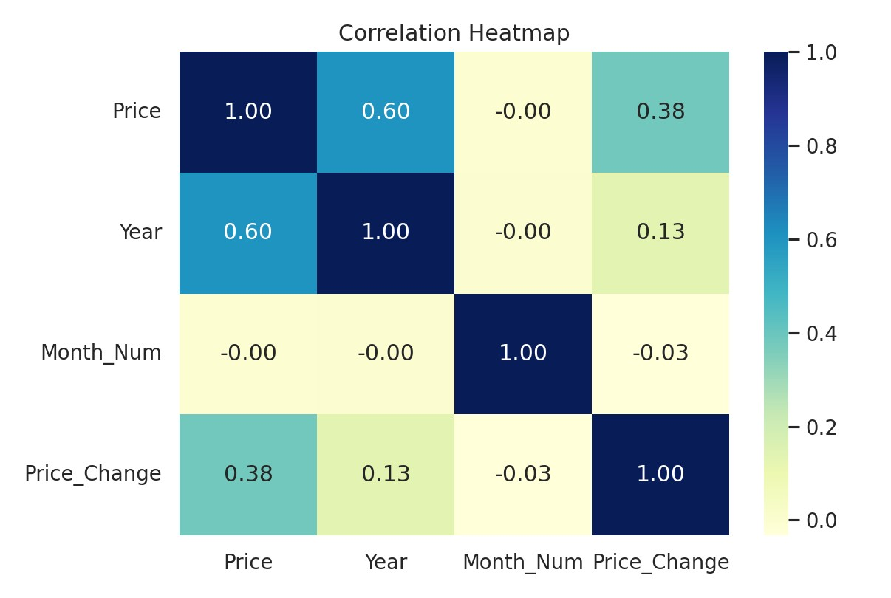
Heatmap interpretation: `Price` has a strong positive relationship with `Year`, showing that gold generally increased in value across the long run.

Simple Prediction Model
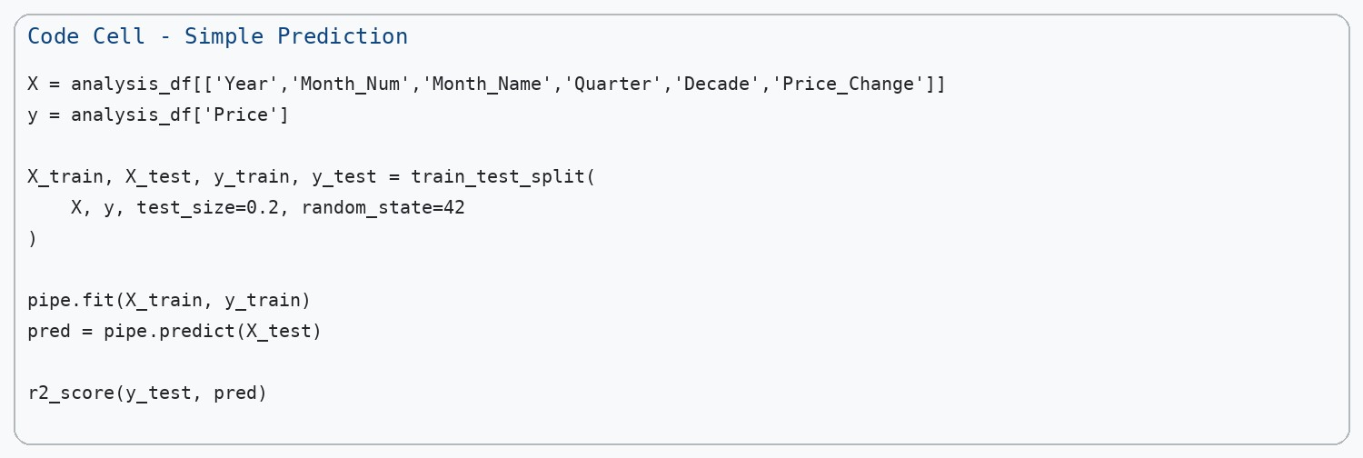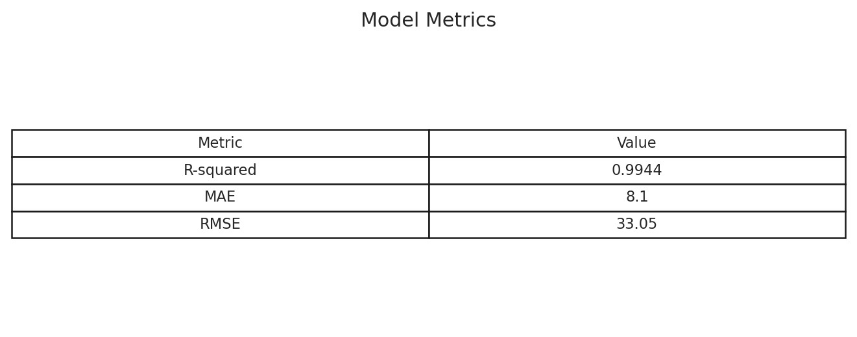
The dataset was split into training and testing parts using an 80:20 ratio. A Random Forest Regressor was used after encoding the categorical columns. The model achieved an R-squared value of 0.9944, which means it explains most of the variation in the test data.
Simple English explanation: The model predicts gold price very well because the year, decade, and recent monthly change already carry strong information about the price level.
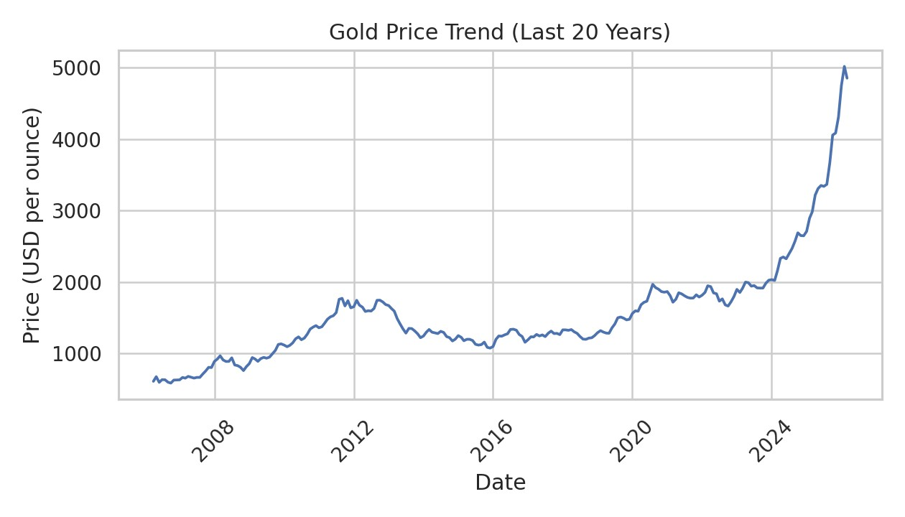
The recent 20-year trend chart also supports the model result because the data contains a clear long-term upward pattern.

Final Insights and Recommendations
Finding 1: The histogram shows a strong right-skew, so very high prices are mostly concentrated in recent years.
Finding 2: The statistics table shows a mean price of 234.23 and a median of 20.68, confirming that newer high prices pull the average upward.
Finding 3: The heatmap shows a strong positive correlation between `Price` and `Year`, which indicates long-term growth in gold prices.
Finding 4: The boxplot shows outliers in `Price_Change`, meaning some months were much more volatile than usual.
Recommendation 1: A non-technical user should focus on long-term trend rather than reacting to one-month jumps, because short-term changes can be noisy.
Recommendation 2: During months with high volatility, buyers and investors should be more careful because the boxplot shows that unusually large price changes do occur.

GitHub Link
GitHub Link: _________________________________

